

**Informal GUI Test**

|  |  |
| --- | --- |
| **TEST CASE** | **DETAILS** |
| 1.Landing Page Loads  (Rendering) | Steps:  1. Open http://localhost:5173/  Expected:  - Logo + brand visible  - Two buttons (Report Lost/Found)  - Recent listings grid shown |

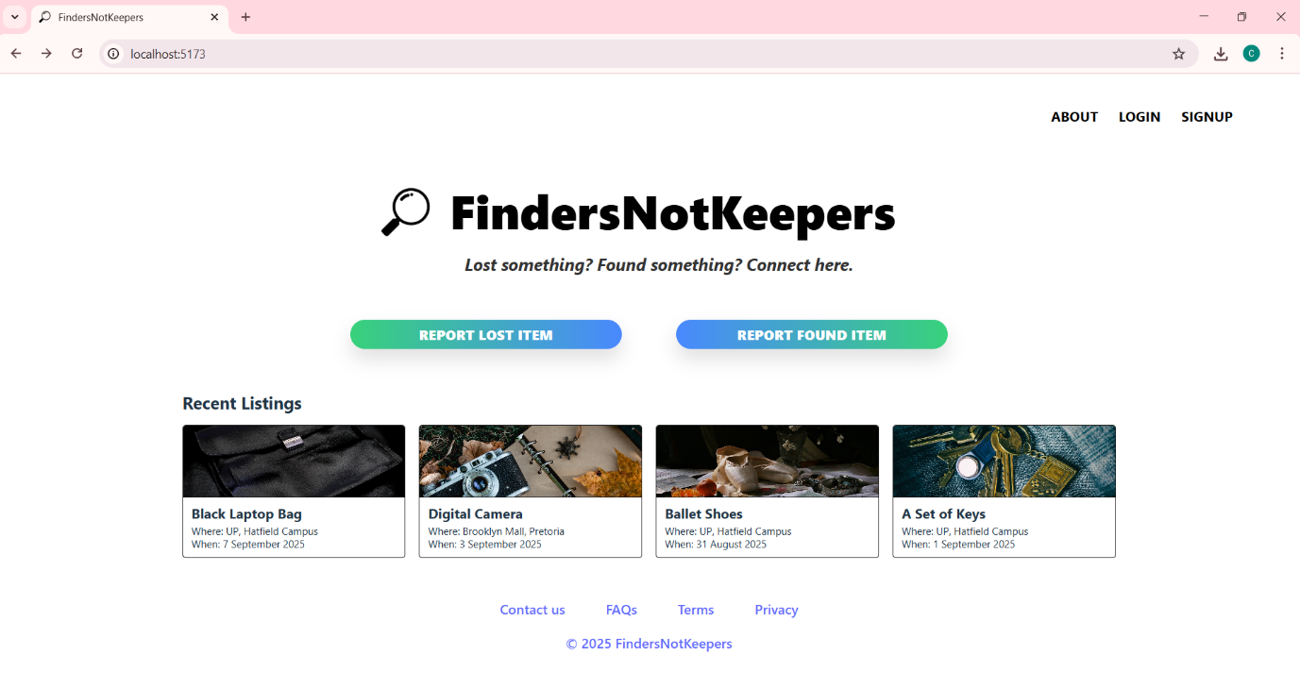

Figure 1: The Landing Page

|  |  |
| --- | --- |
|  | **DETAILS** |
| 2.Login Page – Vali Credentials | Steps:  1. Go to login button as seen as above  2. Enter test@example.com + password123  4. Check if password is longer than 6 characters, if not, there should show an error.  3. Click Login  Expected:  1.Shows error if form not filled.  2.If password is short an error will show.  3.Redirected to /profile (buffer page) |

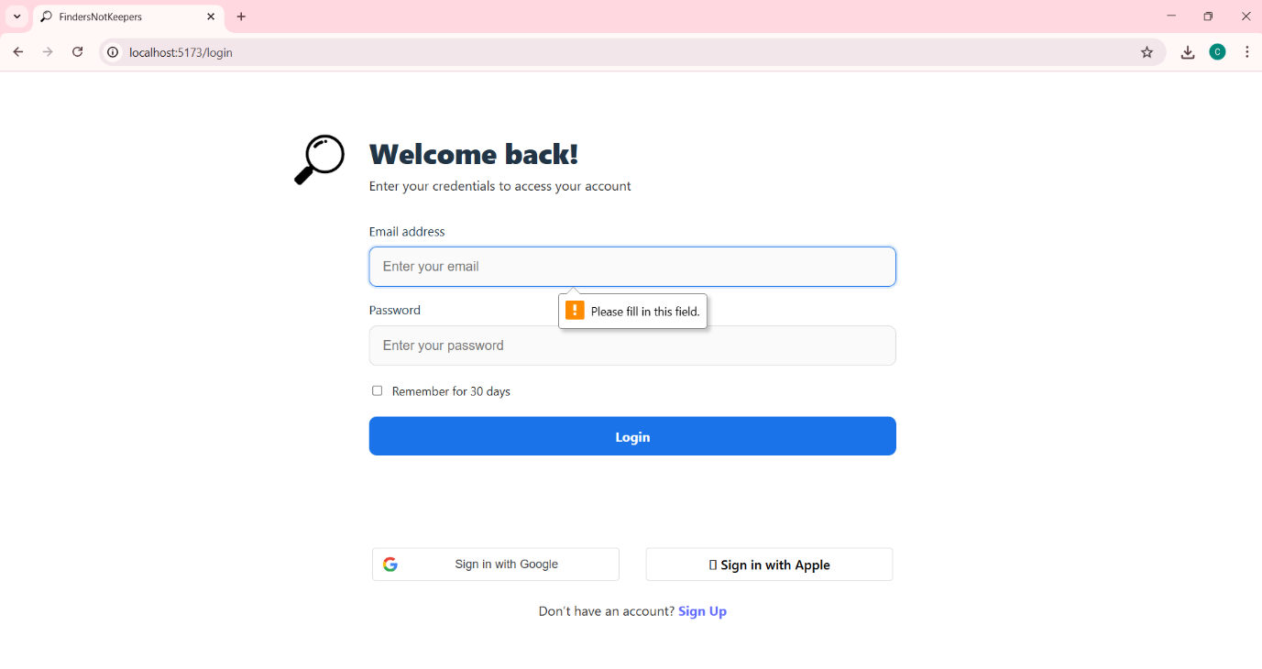

Figure 2: Attempting to Login without Filling in the Form

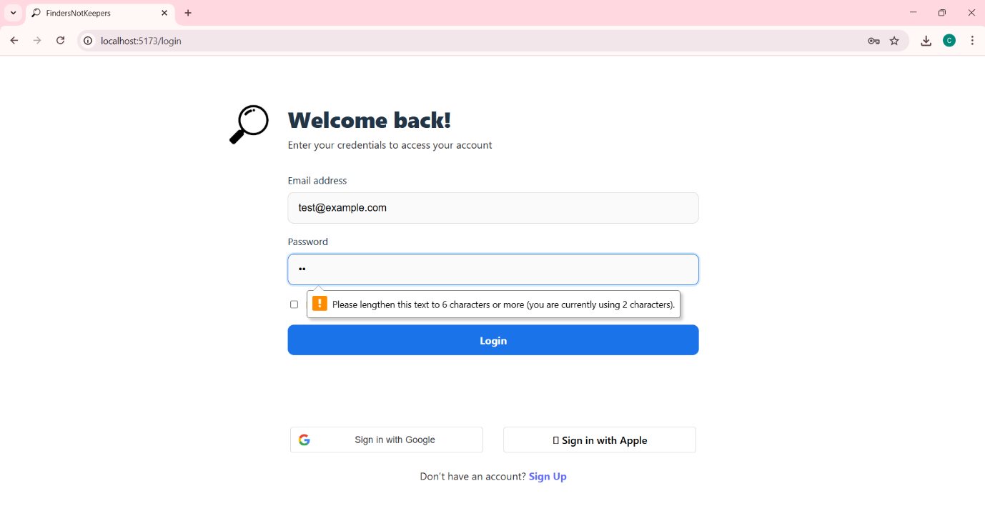

Figure 3: Attempting to Fill in a Password Less than Six Characters



Figure 4: Login Button Leads to Buffer Page (for Now)

|  |  |
| --- | --- |
|  | **DETAILS** |
| 3.Signup Page – Valid Credentials | Steps:  1. Go to sign up button as seen in Figure 1 or http://localhost:5173/signup  2. Enter details, but re-enter incorrect password  3. Click Signup  Expected:  1.Error indicating Password does not match |

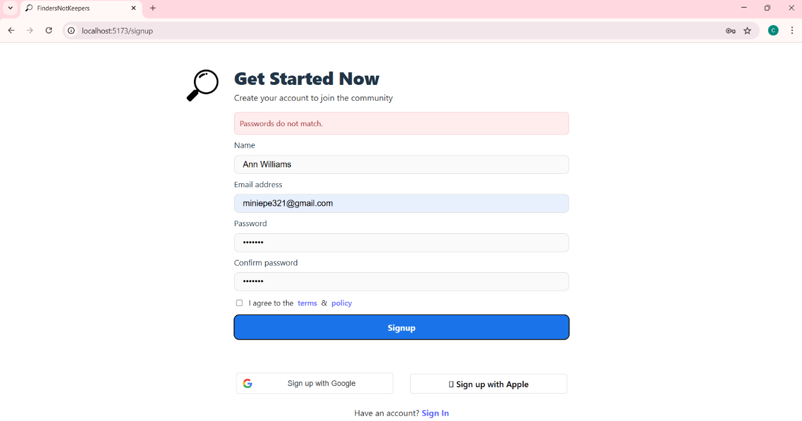

Figure 5: Error Indicating that Passwords do not Match